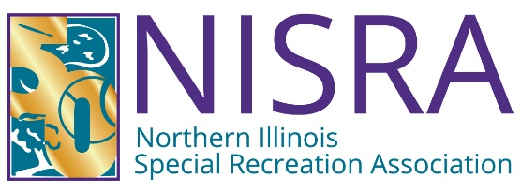

BOARD OF DIRECTOR'S MEETING
WEDNESDAY, August 19, 2026
1:30 P.M. – NISRA Office

AGENDA
1.00 Call to Order

2.00 Recognition of Visitors & Matters from the Public*

3.00 Superintendent’s Report

4.00 Director’s Report

5.00 Consent Agenda Items
5.10 Approval of July 15, 2026 Meeting Minutes
5.20 Approval July 31, 2026 Financial Reports
5.30 Approval of Warrant #4 FY 2026/27

6.00 Old Business

7.00 New Business
7.10 Presentation NISRA Independent Audit Ending April 30, 2026
7.20 Needs Assessment Survey Summary Report
7.30 Appointment of new Board Liaison to the NISRA Foundation Board of Directors

8.00 NISRA Foundation Report

9.00 Comments from the Directors

10.00 Executive Session Pursuant to 5 ILCS 120/2 et seq.
10.10 Personnel
10.20 Pending or Probable Litigation
10.30 Land Acquisition: Purchase/Lease

11.00 Action Regarding Executive Session Items

12.00 Adjournment Next Board of Directors Meeting: Wed., October 21, 2026, 1:30 p.m.

*Matters from the Public: The public is invited to bring to the Board’s attention any matter of public concern not otherwise on the agenda. Public comment may be no longer than 3 minutes per person in duration, with a 30 minute maximum overall. If numerous people want to speak on a single topic, the Board may recognize a specified number of individuals who wish to speak in favor and against the matter and also allow those who wish to make general comments on the issue to do so. The Board shall not be required to allow every person who desires to address an issue to do so, but as many views as possible are encouraged to be heard. Interrogation of the NISRA Staff, Board Members or Legal Counsel will not be allowed at this time, nor will any comment from the NISRA Board, Staff or Legal Counsel. Personal invectives against NISRA Staff, Legal Counsel, or Board Representatives are not permitted.

NOTICE: In compliance with the American With Disabilities Act, this and all other meetings are located in facilities that are physically accessible to those who have disabilities. If additional reasonable accommodations are needed for persons who qualify under the Act as having a "disability", please call the NISRA office at 815-459-0737 at least 72 hours prior to any meetings so that such accommodations can be provided.

