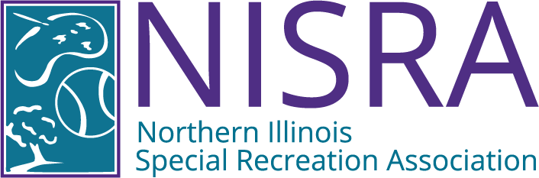

BOARD OF DIRECTOR'S ANNUAL MEETING
WEDNESDAY, MAY 20, 2026
1:30 P.M. – NISRA OFFICE

AGENDA

- Call To Order

- Recognition of Visitors & Matters from the Public*.

- Superintendent’s Report

- Director’s Report

- Consent Agenda Items
5.10 Approval of April 15, 2026 Meeting Minutes
5.20 Approval of April 2026 Financial Reports
5.30 Approval of Warrant #12.5 FY 25/26, & Warrant #1, FY 26/27

- Old Business

- New Business
7.10 Election of FY26/27 Officers
7.20 Approval - FY26/27 Committee Work Plans & Assignments
7.30 FY2025/26 Agency Strategic Plan Goals Completion Report Review

- NISRA Foundation Report

- Comments from the Directors

- Executive Session Pursuant to 5 ILCS 120/2 et seq.
  - Semi-Annual Review of Executive Session Meeting Minutes
  - Personnel
10.12 Pending or Probable Litigation
10.13 Land Acquisition: Purchase/Lease

- Action Regarding Executive Session Items
11.10 Resolution Regarding the Release of Closed Session Minutes

- Adjournment
Next Board of Directors Meeting: Wednesday. July 15, 2026, 1:30 p.m.

*Matters from the Public: The public is invited to bring to the Board’s attention any matter of public concern not otherwise on the agenda. Public comment may be no longer than 3 minutes per person in duration, with a 30 minute maximum overall. Interrogation of the NISRA Staff, Board Members or Legal Counsel will not be allowed at this time, nor will any comment from the NISRA Board, Staff or Legal Counsel. Personal invectives against NISRA Staff, Legal Counsel, or Board Representatives are not permitted.

NOTICE: In compliance with the American With Disabilities Act, this and all other meetings are located in facilities that
are physically accessible to those who have disabilities. If additional reasonable accommodations are needed for
persons who qualify under the Act as having a "disability", please call the NISRA office at 815-459-0737 at least 72
hours prior to any meetings so that such accommodations can be provided.

