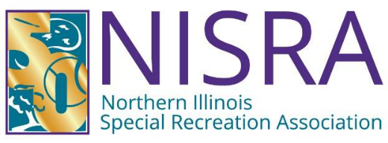

BOARD OF DIRECTOR'S MEETING
Wednesday, October 21, 2026
1:30 P.M. – NISRA Office
AGENDA

1.00 Call to Order

2.00 Recognition of Visitors & Matters from the Public*

3.00 Superintendent’s Report

4.00 Director’s Report

5.00 Consent Agenda Items
5.10 Approval of August 19, 2026 Meeting Minutes
5.20 Accept Finance Committee Report from September 16, 2026
5.30 Approval of August 31 & September 30, 2026 Financial Reports
5.40 Approval of Warrants #5 & #6 FY 2026/27

6.00 Old Business

7.00 New Business
7.10 Health Insurance Plan Selection for 2027
7.20 Approval of FY2027/28 Member District Dues Multiplier
7.30 Proposed Updates to NISRA Organizational Chart
7.40 Review and Approval of Revised Board/Agency Policy 5.06 Boundaries Violations Policy
7.50 Review and Approval of New Board/Agency Policy 5.11 Electronic
Communication with Minors and Vulnerable Adults Policy

8.00 NISRA Foundation Report

9.00 Comments from the Directors

10.00 Executive Session Pursuant to 5 ILCS 120/2 et seq.
10.10 Personnel
10.11 Pending or Probable Litigation
10.12 Land Acquisition: Purchase/Lease

11.00 Action Regarding Executive Session Items

12.00 Adjournment

Next Board of Directors Meeting: Wed., November 18, 2026, 1:30 p.m.

*Matters from the Public: The public is invited to bring to the Board’s attention any matter of public concern not otherwise on the agenda. Public
comment may be no longer than 3 minutes per person in duration, with a 30-minute maximum overall. Interrogation of the NISRA Staff, Board Members or Legal Counsel will not be allowed at this time, nor will any comment from the NISRA Board, Staff or Legal Counsel. Personal invectives against NISRA Staff, Legal Counsel, or Board Representatives are not permitted.

NOTICE: In compliance with the American with Disabilities Act, this and all other meetings are located in facilities that
are physically accessible to those who have disabilities. If additional reasonable accommodations are needed for
persons who qualify under the Act as having a "disability", please call the NISRA office at 815-459-0737 at least 72
hours prior to any meetings so that such accommodations can be provided.

